**CMPE-260 Laboratory Exercise 05**

**Binary Multiplier with Built-In Self Test**

By submitting this report, I attest that its contents are wholly my individual writing about this exercise and that they reflect the submitted code. I further acknowledge that permitted collaboration for this exercise consists only of discussions of concepts with course staff and fellow students; however, other than code provided by the instructor for this exercise, all code was developed by me.

John Judge

John Judge

Performed 4/14/16

Submitted 5/11/16

Lab Section 04

Instructor: Dr. Lou Beato

TAs: Nick Barlow

Sergio Martin

Lecture Section 01

Professor: Dr. Reza Azarderakhsh

**Table of Contents**

1. Abstract …………………………………………………………………………...1
2. Design Methodology………………………………………………………………1
3. Results……………………………………………………………………………..3
4. Conclusion………………………………………………………………………...5
5. Appendix…………………………………………………………………………..5

________________________________________________________________________

**Abstract:**

In this exercise multiple designs were implemented to implement a built-in self-test into a generated multiplier. This design implemented a LFSR to generate pseudo random numbers to multiply and the MISR was used to determine if the signature created was the same for every self-test. In order to complete the design a debouncing unit, Seven-Segment Decoder and Display were added to the project. The project was then simulated using ModelSim and after analyzing the waveforms generated in the simulation and the waveforms were verified to be correct the design was then implemented on a NEXYS 3 Spartan 6 FPGA. The design was then tested again to determine if the design was correct. After several key test cases were tested the design was verified to be correct. The results produced from the simulation and the hardware implementation confirmed a successful exercise.

**Design Methodology:**

*Unsigned 4 x 4 Multiplier*

A 4x4 Multiplier was the first design implemented during the exercise. The multiplier was generated using Xilinx’s built in “IP (CORE Generator & Architecture Wizard).” Using the wizard, the Multiplier was generated with a parallel multiply functionality with the use of LUT’s. The Multiplier generated was capable of multiplication of 4-bit unsigned integers. The result of which was an unsigned 8-bit integer. The objective of this exercise was to determine if the multiplier could be tested correctly through a built-in self-test (BIST). All other components added to the project would be used to determine if the multiplier generated by Xilinx was functional.

*The LFSR*

In order to test the multiplier with random inputs a LFSR needed to be designed. An LFSR creates pseudo random results on the sensitive edge of a clock through the use of D-Flip-Flops and XOR gates. For this implementation it was determined that a Galois LFSR was best for this BIST. A Galois design was preferential over a Fibonacci design because the excess timing delays generated in Fibonacci designs could prove detrimental in hardware. As a result the LFSR was designed in a structural description with four XOR gates and eight D Flip-Flops. A schematic of the design can be seen in Figure (1.0). In the schematic it can be seen that there were no data inputs to the LFSR. Instead, the LFSR reset to its seed on an active high reset. The seed was then the reset value of each of the D Flip-Flops.

In order to have the LFSR cycle between many random combinations the reset value of the D Flip-Flops could not be ‘0.’ Since the only combinational logic that occurred within the LFSR was the XOR gates, ‘0’ could not be used as the seed for each FF because the combinational logic would result in ‘0’ no matter how long the LFSR ran since the last reset. As a result the LFSR would never create pseudo random combinations. To counteract this dilemma a rest value of ‘1’ was used in each of the FF’s. By mapping the wires leaving each FF to the output of the LFSR an 8-bit pseudo random number could be determined on each clock cycle. Since the seed was always set to the same value on reset, each time the LFSR was ran following a reset the output would be the same sequence of the pseudo random numbers. The pseudo random sequence could then be used as the inputs for the Multiplier when using the BIST and if the Multiplier was functioning correctly the output of the multiplier should also follow the same sequence following each reset of the LFSR. The LFSR could therefore be used to test the multiplier in a systematic way while still using random test cases to verify functionality of the multiplier.

*The MISR*

An MISR was then created to analyze the signature created when the BIST was in self-test mode. The MISR had a single 8-bit data-in signal and a single 8-bit data-out signal along with an asynchronous reset. If the rest of the design preformed as desired the LFSR would create the same sequence of pseudo random numbers when in test mode. The multiplier would therefore multiply the same sequence of numbers after entering test mode. The multiplier’s output, or signature, could then be compared after each self-test if the testing period was constant. In order to see the signature the MISR was used to hold the signal output by the multiplier after 100 clock cycles when in test mode. The MISR was designed using an architectural description using D Flip-Flops, XOR gates, and multiplexers. A schematic of the MISR can be seen in Figure (1.1). Essentially the multiplexers allowed for the data-in to reach the data-out except when a counter reached the desired period. When the desired period was reached the multiplexers provided the data-in or each FF with that FF’s data-out, thus holding the signature.

Using this design required that the FF’s reset to ‘0’ instead of ‘1’ like the FF’s in the LFSR. The reset signal would therefore be an 8-bit vectors of all 0’s and this value would hold until the data-in of the MISR was changed to a non 0 value. The MISR was then able to the data out of the multiplier to flow out of it for each clock cycle but hold the output after the desired amount of time. Using this signature by each self-test the Multiplier could therefore be verified to be operating correctly.

*The Top Level Wrapper*

In order to properly test the functionality of these units a top-level wrapper needed to be designed. The wrapper was designed using an architectural description which instantiated and mapped the components together. A schematic of the top-level wrapper as well as its interconnections and sub-components can be seen in Figure (1.2). The wrapper had a 1-bit *test_mode* signal, 2 4-bit data-in signals named *A* and *B*, as well as *clk* and *reset* signals. The wrapper also had a single 8-bit output. The clock signal was then mapped to the LFSR and the reset signal to both the MISR and LFSR. Then 3 2-1 multiplexers were instantiated using a file developed in a previous exercise. Two of these multiplexers were used to determine whether the input signals to the multiplier were the input signals *A* and *B* or the output of the LFSR using the *test_mode* signal as a select. These, therefore, allowed for the multiplier to multiply any signals desired when not in test mode but only the output of the LFSR when in *test_mode*. The last multiplexer also used *test_mode* as a select but it determined whether the output of the wrapper was the output of the MISR or LFSR. This multiplexer would therefore ensure that the signature determined by the MISR would not change when in *test_mode*.

The wrapper was then adjusted so that the output could be displayed when it would later be routed to the FPGA. Using the Seven Segment Decoder and Display developed in a previous exercise, the output of the final stage multiplexer was then converted into binary coded decimal and mapped to the seven-segmented display. In order to work correctly with the buttons of the FPGA the denouncing code supplied in this exercise was used to debounce the reset signal. The code was added to the project within its own entity called Debouncer. The Debouncer had a single signal, the global reset, and a 1-bit output, which was the debounced, reset signal, which was then mapped to the reset ports of the LFSR and MISR units. These added units would later allow the design to be verified when implemented on the FPGA.

**Results:**

*The Design of the Test Benches*

In order to test the code developed during this exercise a multiple test benches were created to test the components of the self-testing circuit. First a test bench was designed for the multiplier to ensure that Xilinx had generated a sufficient 4 x 4 multiplier capable of multiplying unsigned 4-bit integers. Next, test benches were created to verify the LFSR and MISR operated as desired. Finally, a test bench was created for the entire circuit and tested its functionality when for manual tests and self tests. Behavioral and post-route simulations were then used to verify the circuit had been correctly designed.

*The Results of the Multiplier Test Bench*

The test bench associated with the multiplier was used to determine if the 4 x 4 multiplier was generated correctly. In this test bench the inputs for the multiplier were driven as if the multiplier was in a manual test mode. If the multiplier was functioning correctly it could be easily verified by determining if the arithmetic preformed was correct. The associated waveforms for the test can be seen in Figure (1.3). In this figure the radix of the waveforms were changed to unsigned decimal for ease of verification. The multiplier’s output changed on the rising clock edge following a change in input. The test cases shown in Figure (1.3) were chosen at random. Testing all possible combinations of the 4-bit inputs would have been far to exhaustive and unnecessary in determining if the multiplier was functioning correctly. Instead the test cases shown were used and since the multiplier correctly handled all the operations it can be concluded with almost certainty that the multiplier would work for all possible 4 x 4 multiplication. Following this simulation test benches were created to test the self-testing portion of the circuit.

*The Results of the MISR Test Bench*

Next a test bench was created to test the MISR. In order to verify the MISR would work correctly when implemented in the BIST circuit its functionality to hold the signature after the desired period needed to be tested. Consequentially this test bench was created using a for-loop to cycle the data-in of the MISR in an infinite cycle. If the MISR was working correctly, it would stop after the desired period of 120 clock cycles had been reached following an rising edge of the *test_mode* signal and hold its current value. A waveform capture from this test bench’s simulation can be seen in Figure (1.4). As seen in the capture, the MISR held the signature despite the inputs consistently changing after the period of testing had been reached. It is important ot note that the signature collected from this test would nto be the same signature recorded in future tests. This is because the input of the MISR would be different that the values used in this test bench. Since the MSIR held a value after the desired period was reached it was determined that the MISR was functioning correctly and would hold the correct signature when used in conjunction with the multiplier and LFSR.

*The Results of the LFSR Test Bench*

The last component that needed to be tested before the circuit was tested as a whole was the LFSR. In order to verify the LFSR would operate correctly in the BIST its ability to output a new signal every clock edge, as well as its ability to stop outputting pseudo random signals when not in test mode needed to be verified. This was done by simply driving the signal for the LFSR’s *TestMode* input to ‘1’ while *Reset* remained low. The LFSR was then left to create a pseudo random numbers for many clock cycles and then the *TestMode* signal was set to ‘0’ and the LFSR was reset. A capture of the waveform can be seen in Figure (1.5). As seen in the capture, the LFSR created a string of pseudo random numbers when in test mode but once not in test mode and in reset its output stayed constant. This ensured that when the LFSR was implemented into the design it could be reset and regenerate the same string of pseudo random numbers whenever reset and test mode was entered. After this test it was determined that all the individual components of the LFSR were working and the design could be tested form the top-level wrapper.

*The Results of the Behavioral Simulation*

The entire design was then tested from the top-level block diagram to ensure that the sub-components interacted as desired when connected to one another. A test bench was then created to test the circuit’s capability to preform manual tests as well as self-testing. In this simulation, if the signature held by the LFSR was for multiple self-tests the design could then be considered to be correctly implemented. A capture of the waveform generated by ModelSim from this test bench can be seen in Figure (1.6).

In the waveform capture it can be seen that first the manual testing capability of the circuit was tested. By driving the input signals of *A* and *B* with the same test cases used in the Multiplier’s test bench while *test_mode_in* remained low the circuit behaved as expected and provided the same results as the multiplier’s test bench. This verified the design could correctly behave in the manual test mode.

The design was then tested with the BIST functionality. The *test_mode_in* signal was driven to ‘1,’ thus entering test mode and all the multiplexers switched what inputs they accepting appropriately. As seen in Figure (1.6), the LFSR began creating pseudo random numbers for the multiplier to multiply on each rising clock edge. The MISR then controlled what the output of the circuit was up until its counter signal reached the desired period of 120 clock cycle. At that point the LFSR reached its steady state response and the signature produced was noted. The circuit was then reset and a few manual tests were conducted, different from those previously used. This ensure that if the next signature produced would not be a function of the manual tests occurring before the BIST. The circuit then entered the BIST mode until another signature was produced. The signature produced during this test matched the one derived in the previous self-test. This proved the BIST functionality was working as desired and the multiplier was also preforming the same operations during each test.

It was also noted that during this simulation the correct signals were driven to the output of the seven-segmented display. This ensured that when the design would later be implemented on the FPGA that the results of the testing could be seen and verified to be working correctly. From here an analysis needed to be done to ensure that the design would be functional when the delays associated with hardware were accounted for.

*Results of the Post-Route Simulation*

Following the Behavioral testing a Post-Route simulation took place in order to simulate the delays to be expected in the hardware implantation. During this simulation the same test bench used for the behavioral simulation was used. A portion of the resulting waveform can be seen in Figure (1.7) where the delays between the change in input and change can be seenof the results recorded in the post-route simulation matched the expected results of the behavioral simulation but with delays on the clock-to-output times. That is, except the seven-segmented display results, this was due to an issue with the signals being driven by the test bench operating in a higher frequency than the clock. The design still functioned correctly and it was determined that this issue would be solved once the design was implemented on the FPGA. Since the post-route simulation did not result in any undesired results it was concluded that the design was ready to be implemented on the FPGA and further testing could be done.

*FPGA Implementation*

Following the post route simulation the design was routed to the NEXYS 3 FPGA and was tested using the board’s switches to represent all bits of the inputs *A* and *B*. The buttons were used for the *reset* and *test_mode_in* signals. Three of the four possible seven-segmented displays were used to show the result of any operations carried out whether in test mode or manual testing. The design was then tested using similar test cases to those used in the Top-Level Wrapper’s test bench. In all of these tests the board responded appropriately. The resulting signatures derived by the BIST matched the signature from the behavioral and post-route simulations. As a result the BIST and generated multiplier could then be verified to be functioning and the design summary was then consulted.

*Design Summary*

The Design Summary tab of the project was then consulted to check the occupied number of slices, flip flops, and LUTs. A capture of the design summary can be seen in Figure (1.8). Based on the Design summary the project used a total of 123 LUTs as well as 88 Flip Flops for a total of 46 slices. The design therefore used 2% of the total amount of slices available in the FPGA.

**Conclusion:**

There were some lessons to take from doing the exercise. The most major of which was the implementation and use of MISR’s and LFSR’s. The design and use of self-testing circuits was also explored for the first time. Although some minor bugs due to timing errors occurred following synthesis, changing how the debouncing was handled eventually rectified the problems. Once rectified the design was properly synthesized an implemented on the FPGA. Following some more testing the self-testing function, as well as the rest of the design, was verified to be correct. Overall, the exercise was conducted successfully, with the generated multiplier and the self-test operating correctly. As a result this exercise can be used as an example of how to correctly implement a self-testing design.

**Appendix:**

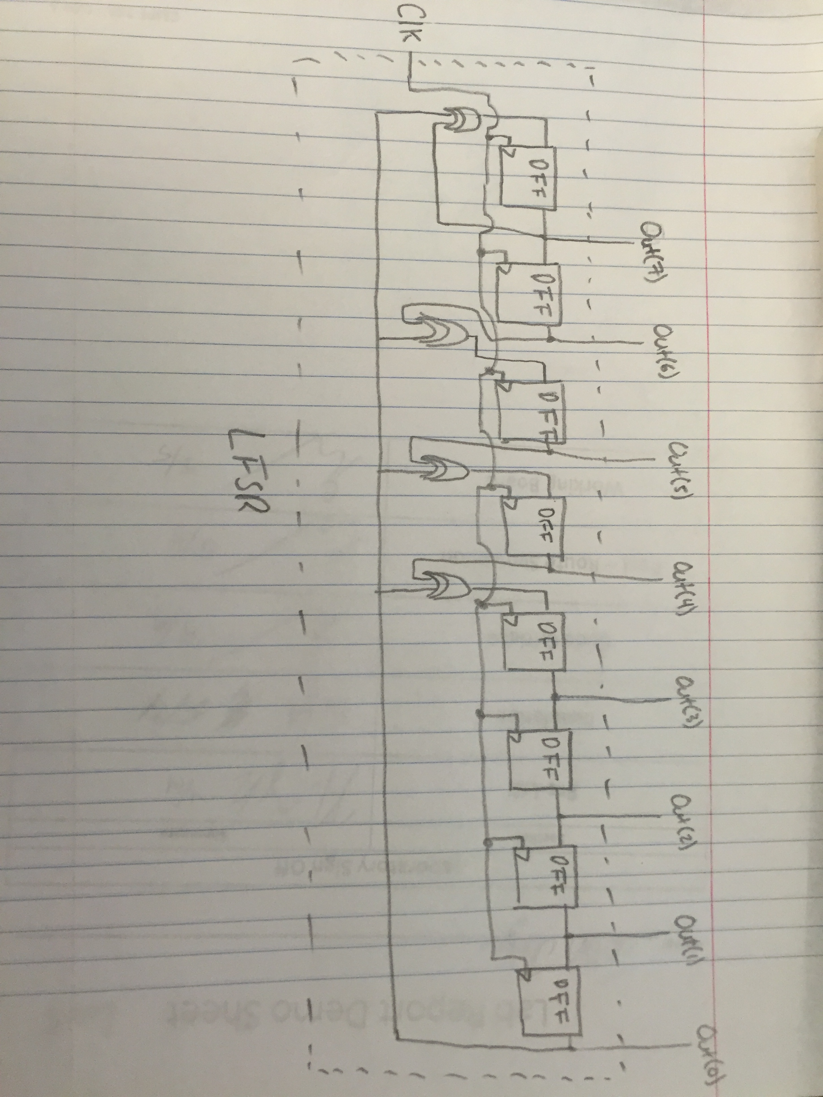

Figure (1.0): The LFSR

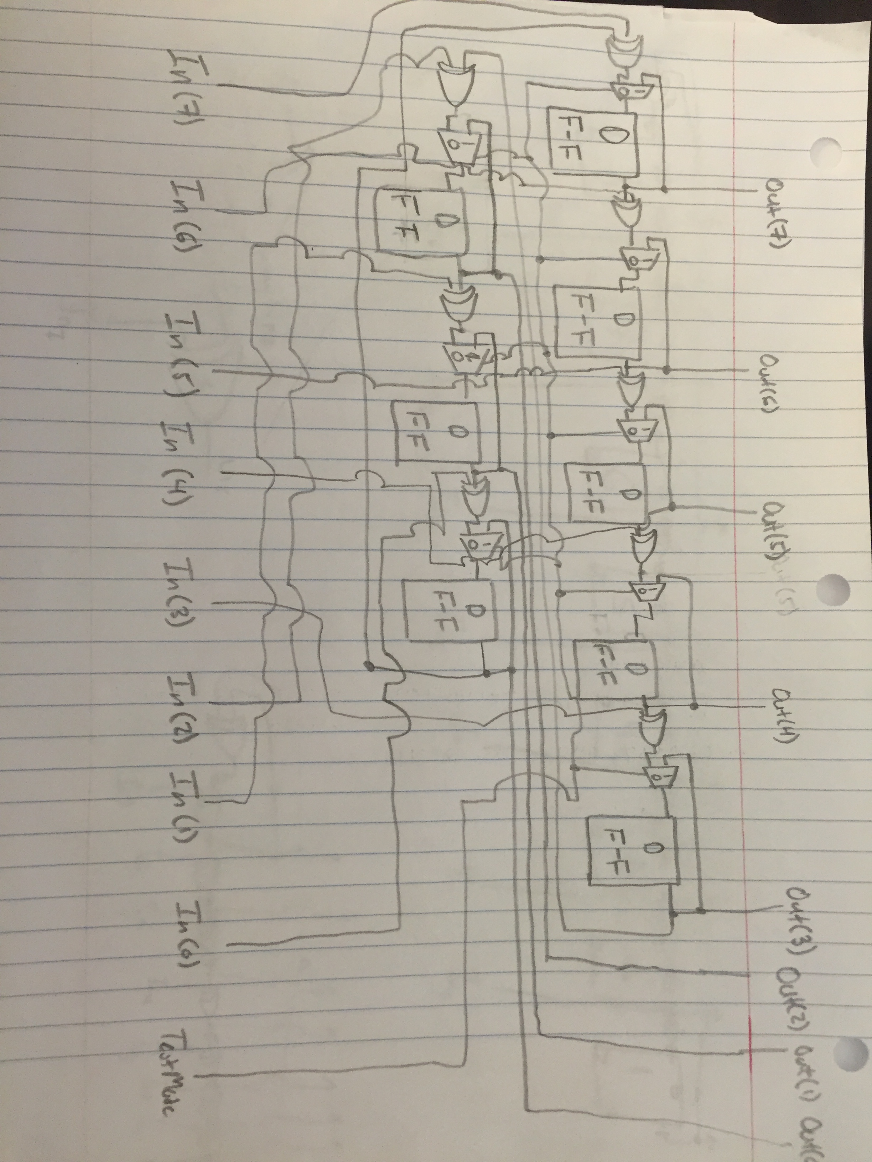

Figure (1.1): The MISR

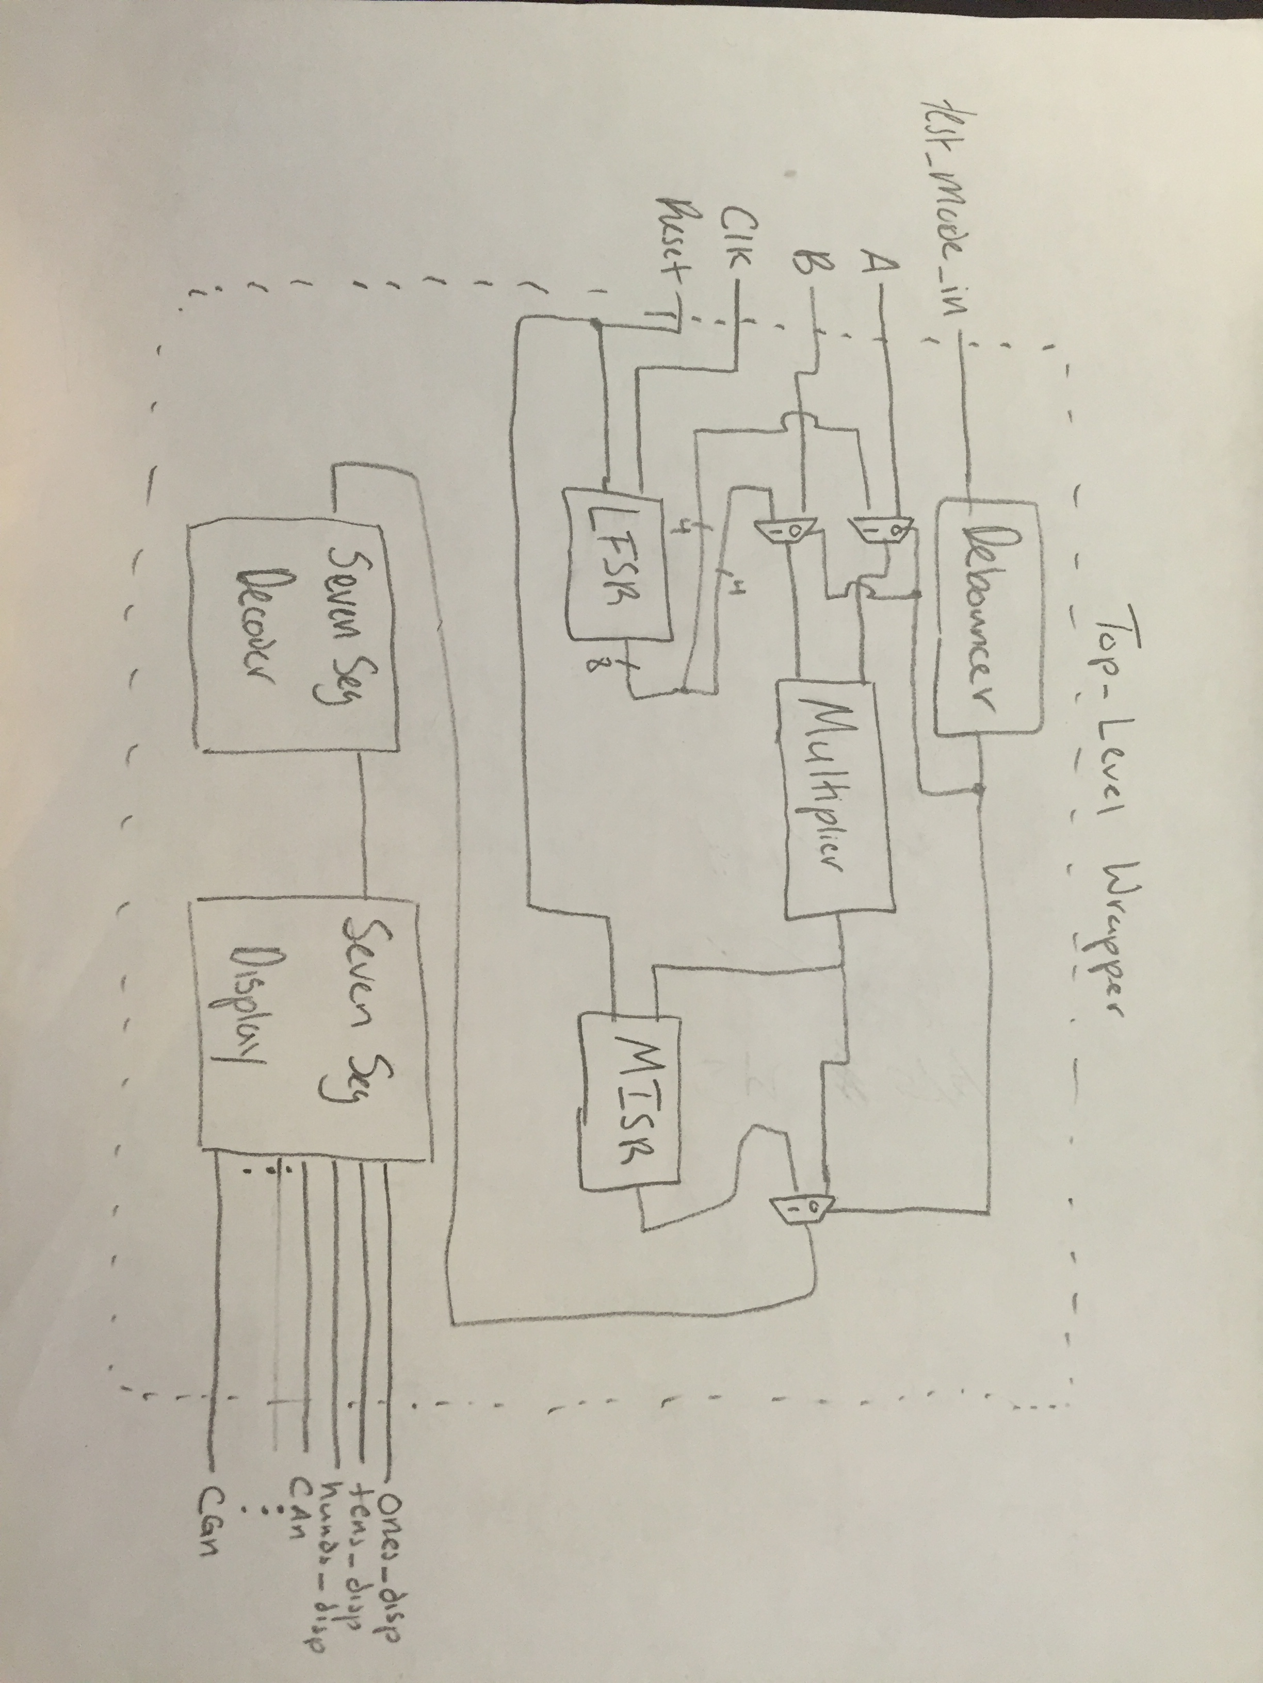

Figure (1.2): The Schematic of the Multiplier with BIST

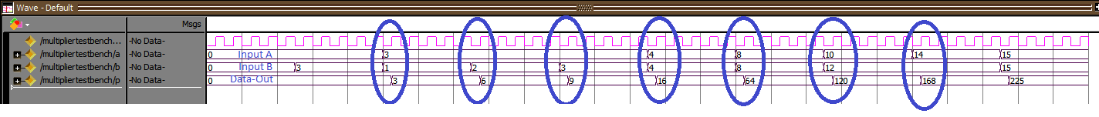

Figure (1.3): The Multiplier Test Bench Results

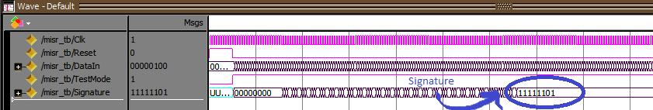

Figure (1.4): The MISR Test Bench Results

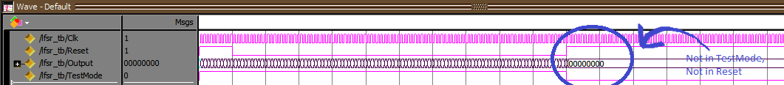

Figure (1.5): The LFSR Test Bench Results

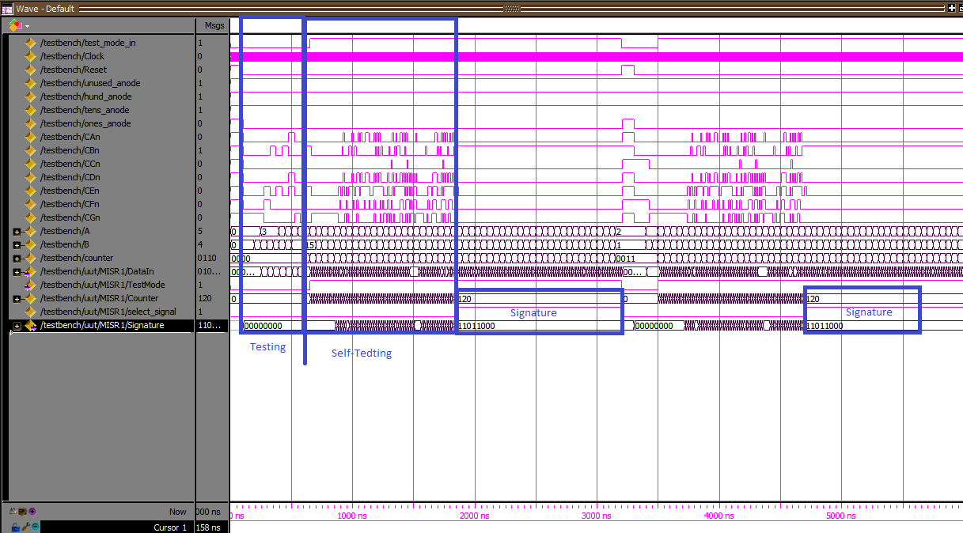 Figure (1.6): The Behavioral Simulation Results

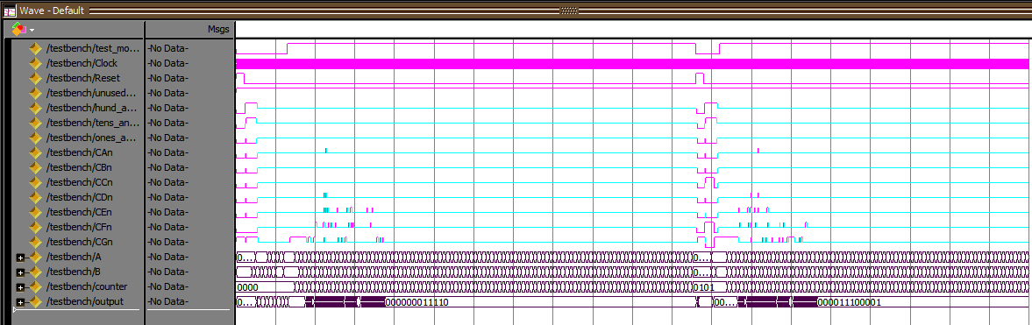

Figure (1.7): The Post-Route Simulation Results

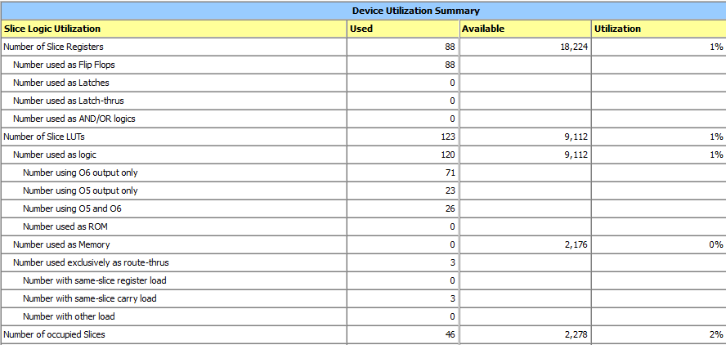

Figure (1.8): The Design Summary

